**Laboratory Report   
DeVry University  
College of Engineering and Information Sciences**

**Course Number: DBM405A**

**Professor: Lively**

**Laboratory Number:** 6

**Laboratory Title:** Adding, Changing and Deleting records

**Submittal Date:** 6/9/2015

Note: There is no limit on how much information you will enter under the three topics below. It is important to be clear and complete with your comments. Like a scientist, you are documenting your progress in this week’s lab experiment.

**Objectives:** In your own words, what was this lab designed to accomplish? What was its purpose?

The objective of this lab was to have us work with stored procedure functions, link our table to a programming language in order demonstrate a call of the procedure, and also set up an event that again demonstrates the functionality of backing up the database. All of these were new concepts outside of backing up, but we did achieve the backup in a new manner through the use of an event. Stored procedures were the main point of interest and creating the procedure as well calling it from within the IDE of Workbench as well as using an external programming language to write a program which uses the stored procedure were the areas that by far took the most amount of thought at work.

**Results:** Discuss the steps you used to complete your lab. Were you successful? What did you learn? What were the results? Explain what you did to accomplish each step. You can include screen shots, code listings, etc. to clearly explain what you did.

Please see the following code/screenshots with comment annotation for each number/step of the lab to see how each step was successfully achieved. Please note each highlighted step, and its ensuing successful output:

#1

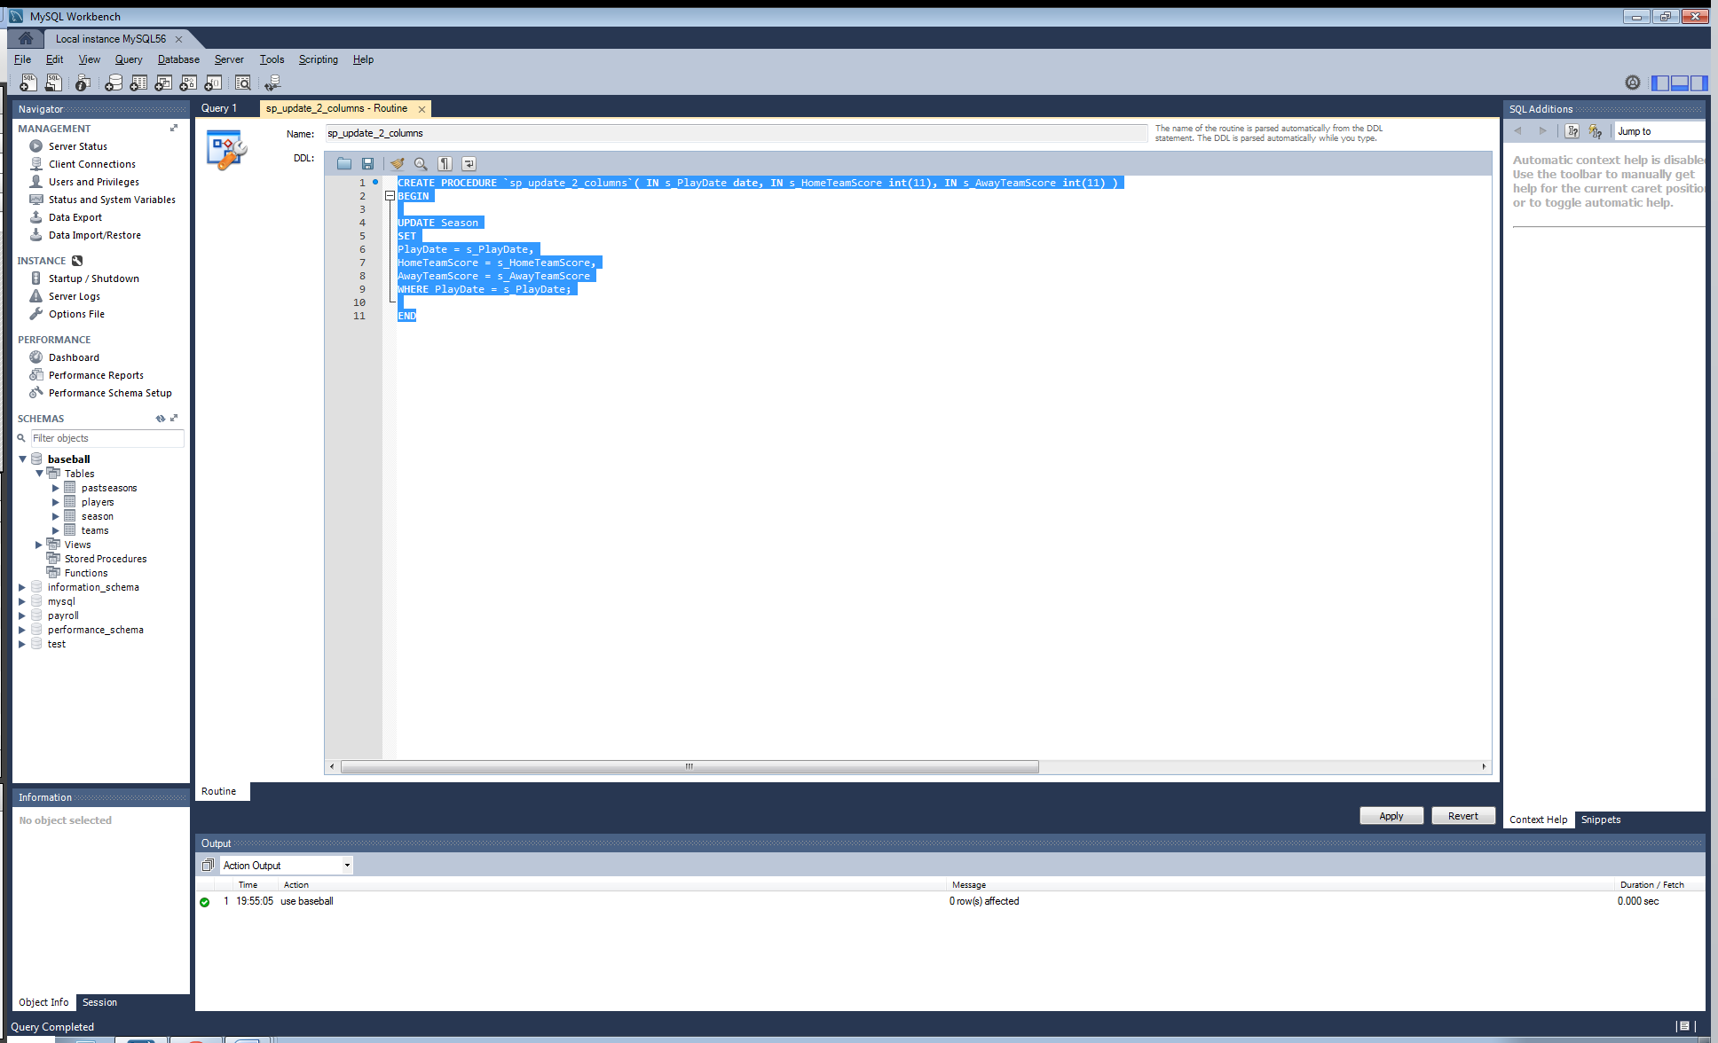

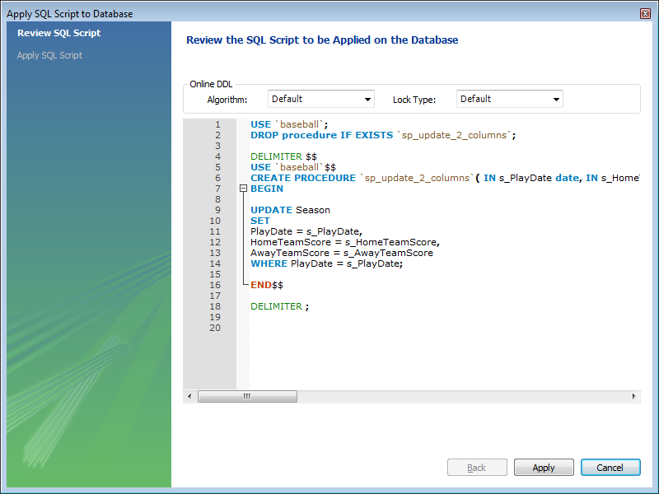

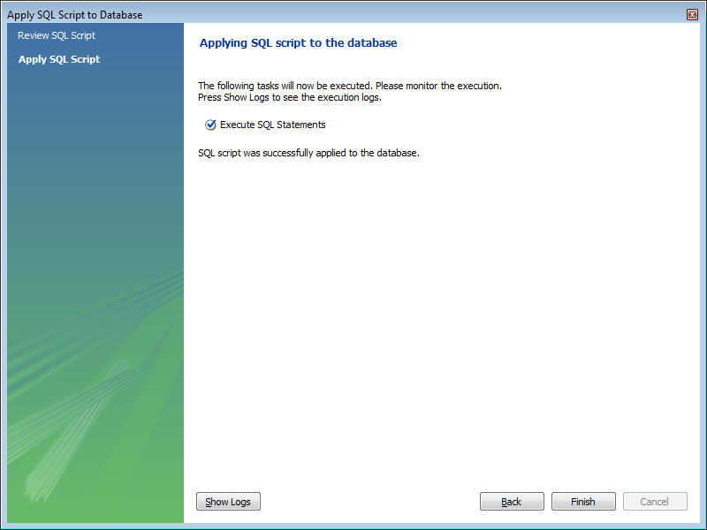

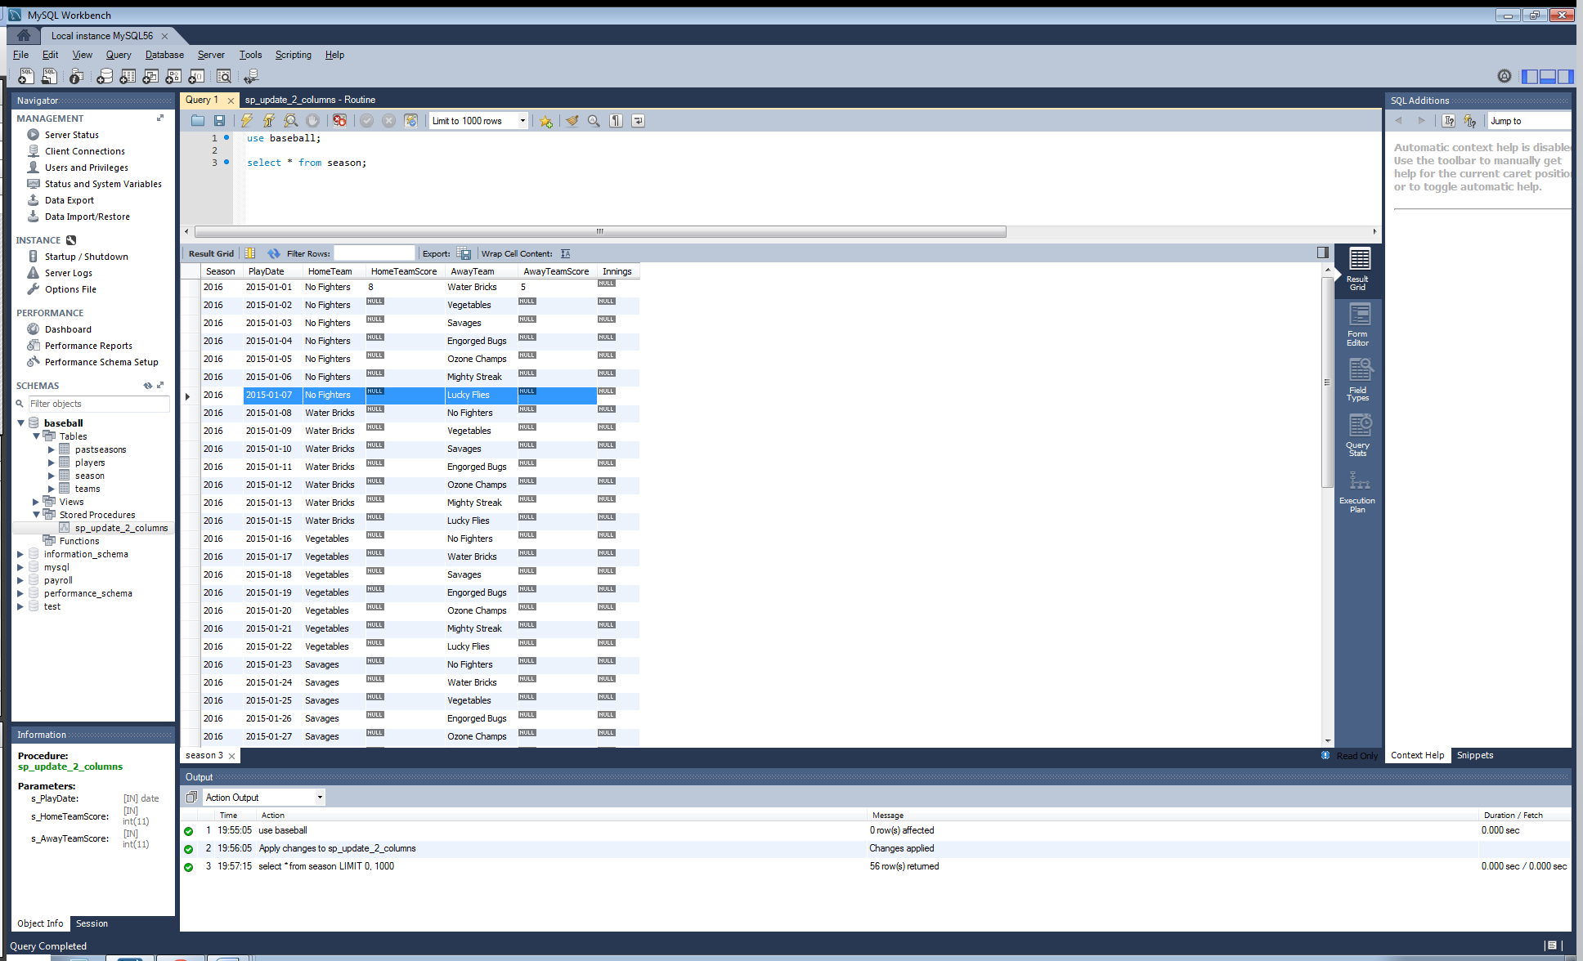

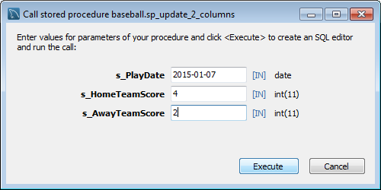

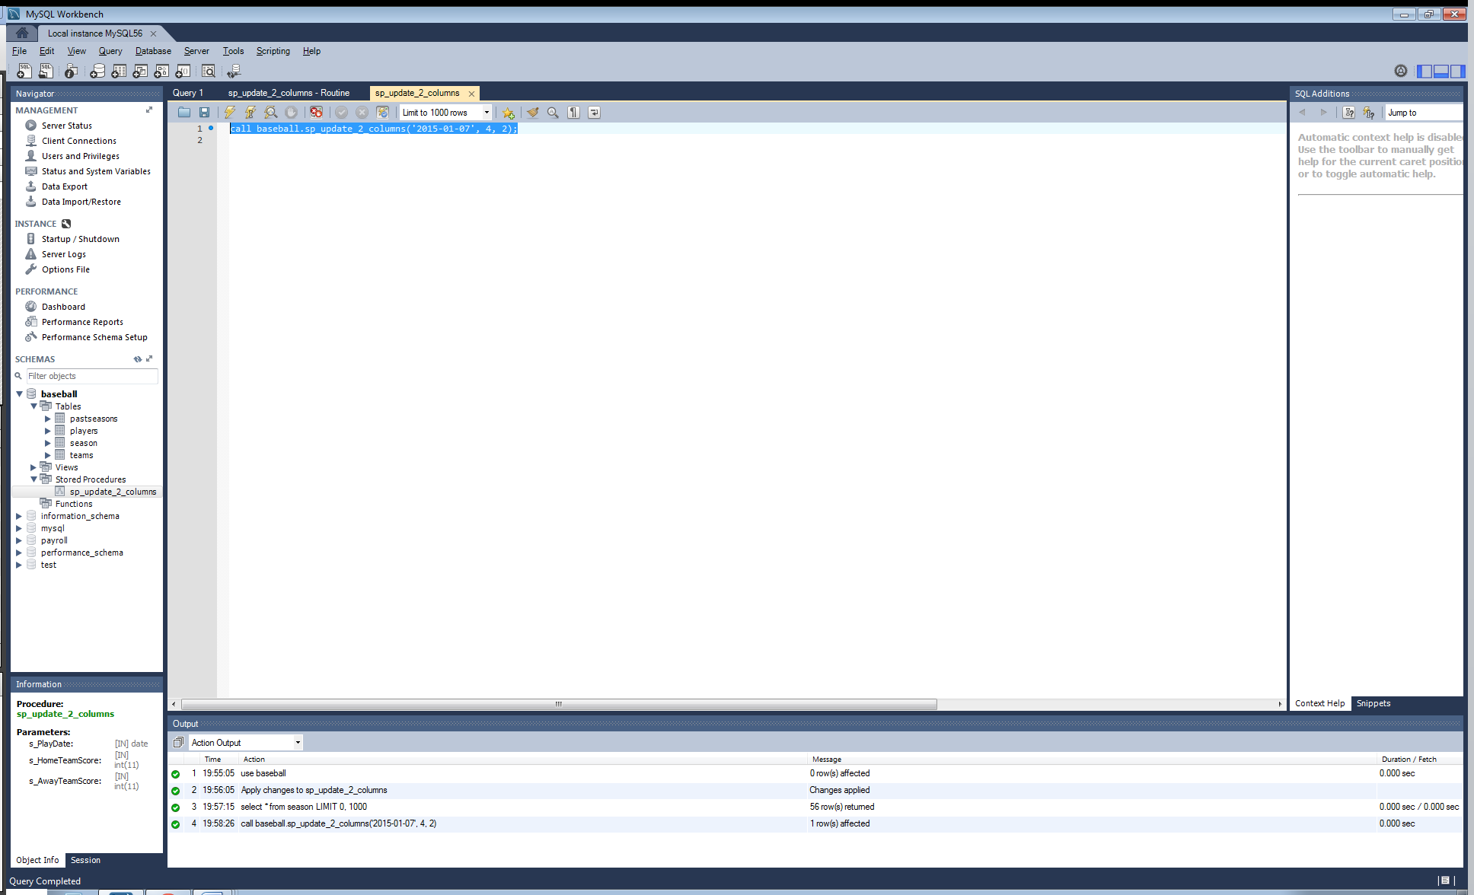

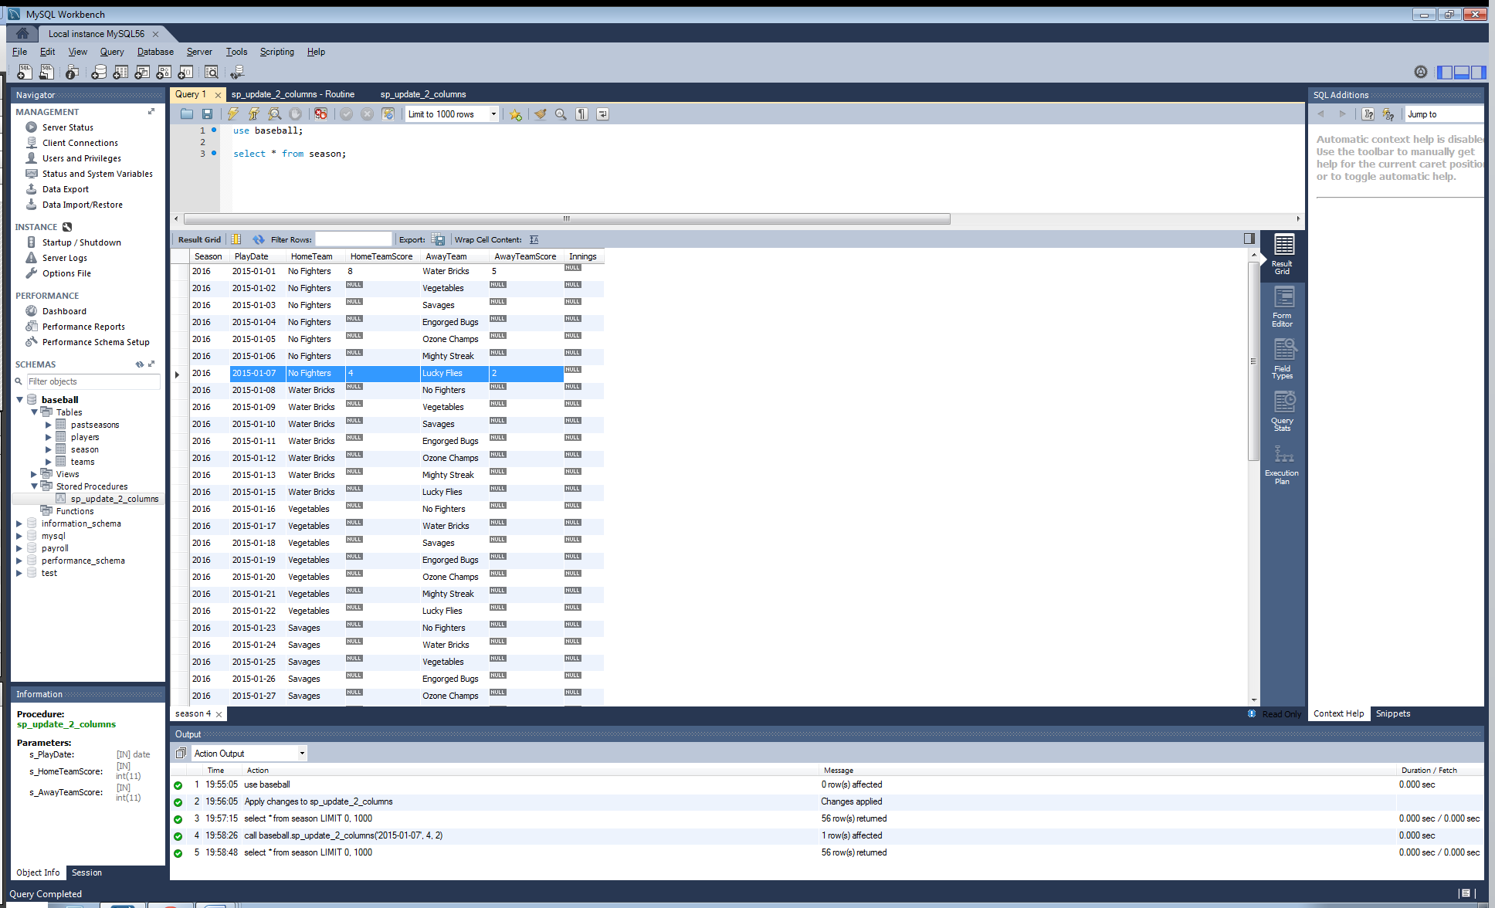

#2

Please note the highlighted code which calls the stored procedure, as well as the code at the top of the window which imports the MySQL connector, creates a connection, the defines a cursor object. Also note the data before the call, and after to verify the change.

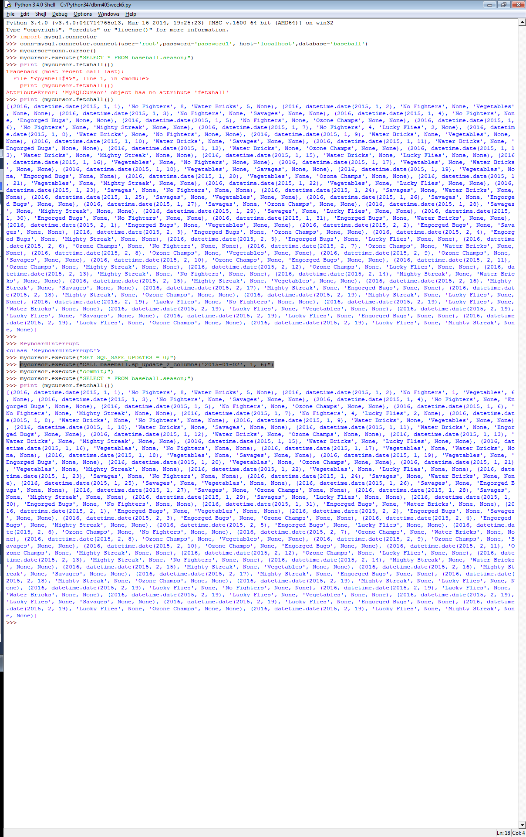

#3

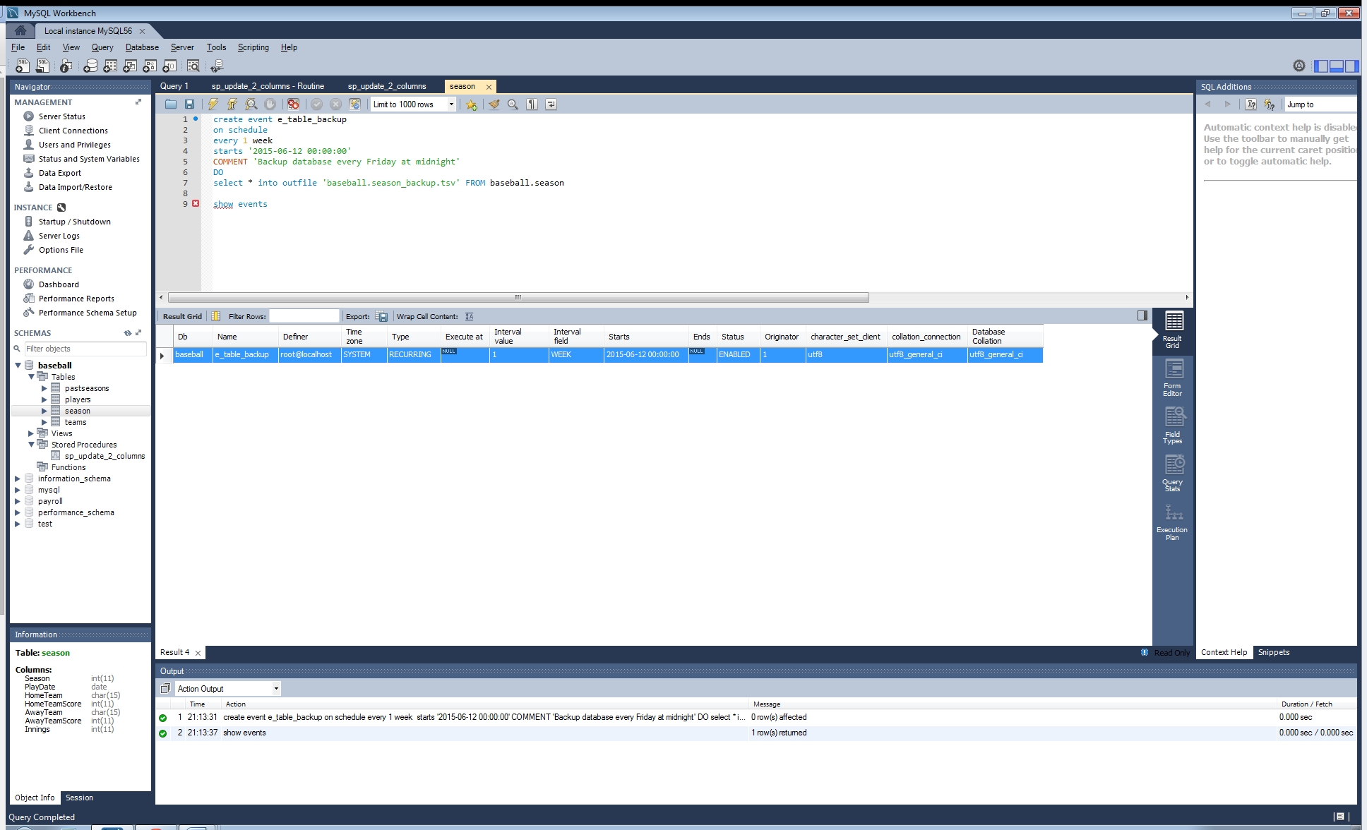

**Conclusions:** After completing this lab, in your own words, what conclusions can you draw from this experience?

Stored procedures are critical functions to working with a database. Through these procedures we can externally send/call functions that allow data to be changed through the use of the function we create. Essentially we create the procedure with some parameters, in this case we tell it to update HomeTeamScore and AwayTeamScore with the desired values based upon the PlayDate entered. Connecting the database to a programming language is a new concept for the labs, but one we have practiced in the course project thus far. From here we can combine the power of a programming language and use it to manipulate our database in any way we desire. A simple connection to the server and declaration of code allowed us to perform the call and update the appropriate data in our database based upon the stored procedure call. The idea was not to create something complex in the programming language, just demonstrate the connection capability and show that the database can be updated externally by a programming language/application, similar to our course project. Stored procedures are highly important to the security of the database as we can write the code to the server, but make the call and execute the function in a user application.

|  |  |  |  |  |  |
| --- | --- | --- | --- | --- | --- |
| **Student:** | Anthony Meunier |  | CIS |  | Anthony Meunier |
|  | Name |  | Program |  | Signature |